WEEK #1
Fundamentals of IT: MS Word and MS Excel

OBJECTIVES : To help the students in learning the practical use of MS-Word, MS-Excel.

OUTCOMES: After completing this, the students would be able to:
Use MS-Word, MS-Excel in real-life applications.

PROBLEMS:
Problem 1. Open a new document and type the following letter.
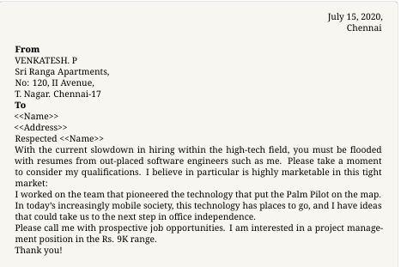
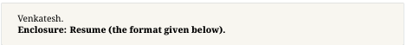
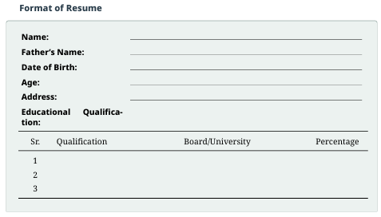
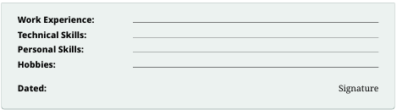

July 15, 2020,
Chennai
From
VENKATESH. P
Sri Ranga Apartments,
No: 120, II Avenue,
T. Nagar. Chennai-17
To
«First_Name»
«Address_Line_1»
Respected <<Name>>
With the current slowdown in hiring within the high-tech field, you must be flooded with resumes from out-placed software engineers such as me. Please take a moment to consider my qualifications. I believe in particular is highly marketable in this tight market:
I worked on the team that pioneered the technology that put the Palm Pilot on the map. In today’s increasingly mobile society, this technology has places to go, and I have ideas that could take us to the next step in office independence.
Please call me with prospective job opportunities. I am interested in a project management position in the Rs. 9K range.
Thank you!
Venkatesh.

Enclosure: Resume

Name: Ankita Maurya
Father's Name: Mr. Anil Kumar Maurya
Date of Birth: 04-080-2004
Age: 22
Address: abc, xyz
Educational Qualification:
Sr. | Qualification | Board /University | Percentage
1. | High school | CBSE | 85.4
2. | Intermediate | CBSE | 89.8
3. | Graduation | RMPSU | 78.6

Work Experience: xyaz
Technical Skills: hajs
Personal Skills: huh
Hobbies: hsid
Dated: 12-03-2026 Signature

––––

1. Save the document as “Letter.doc.”
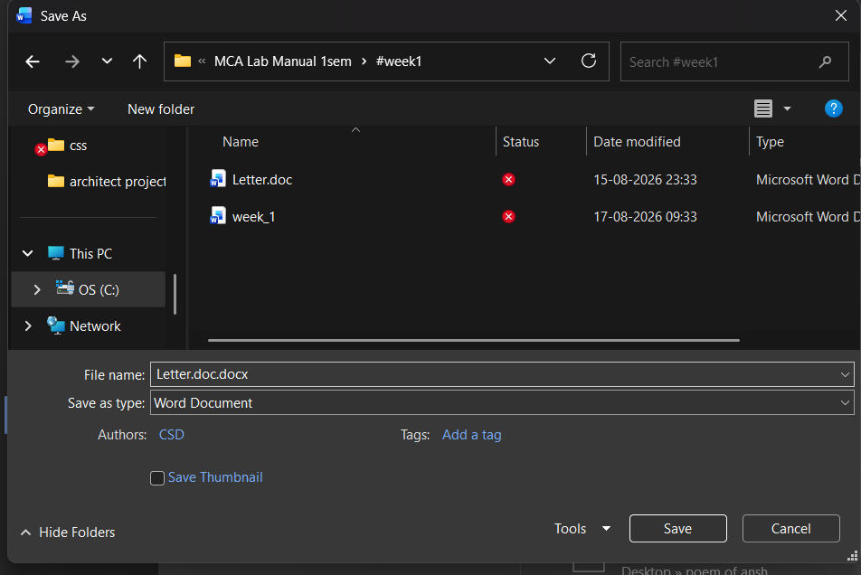

2. Send the document to 3 recipients using Mail merge. (Use 3 different addresses)
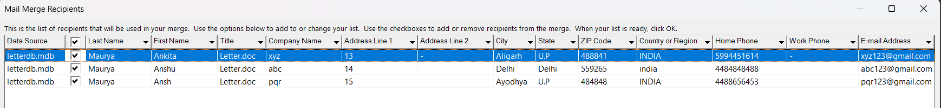

3. Define a Macro “Decorate” which makes the text bold ,Red in colour and italic ,font size Assign a shortcut key Alt+Z to this macro.
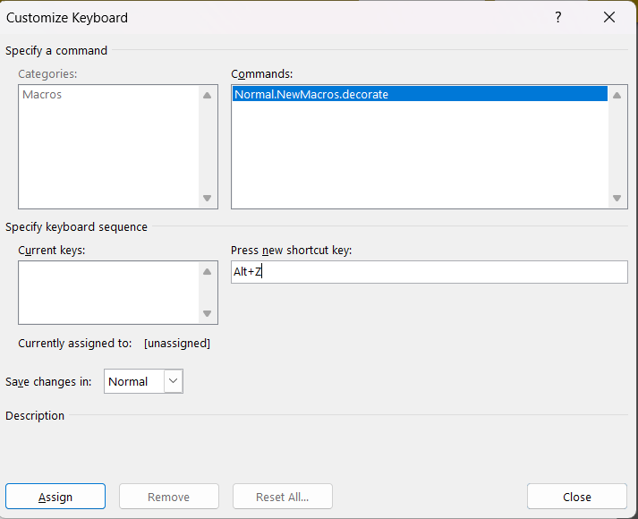
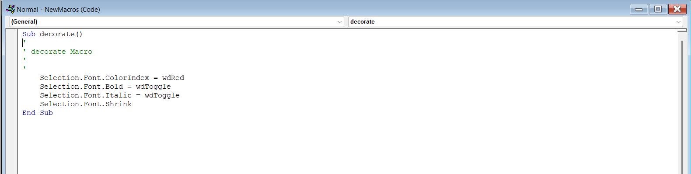
4. Close the document.
5. The Sample Addresses are:
a. Mr. Amit Tandon, 13, New Estate, Ring Road, Chandigarh
Roll no. | Name | Marks in Physics | Marks in Chemistry |  | Total Marks
1. | Sakshi | 80 | 70 | 150
2 | Rohit | 70 | 80 | 150
3 | Amit | 60 | 50 | 110
4 | Rakesh | 40 | 60 | 100
5 | Komal | 30 | 70 | 100
6 | Garima | 80 | 80 | 160
b. Mr. Rohit Saluja, 15, Karol Bagh, New Delhi
c. Ms. Jyoti Parmar, Sector 16, New Building, Gurugram

Problem 2. Create a table in Word as shown below:
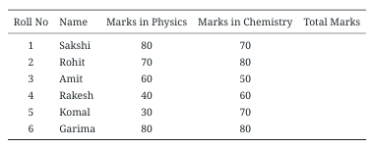

▶ In the total marks’ column, entries should be calculated using formulas and it is the sum of
marks in physics and marks in chemistry.
ANS: By using formula : =sum(left)
▶ Insert a new row at the end of the table and also find grand total using formula.
Roll no. | Name | Marks in Physics | Marks in Chemistry |  | Total Marks
1. | Sakshi | 80 | 70 | 150
2 | Rohit | 70 | 80 | 150
3 | Amit | 60 | 50 | 110
4 | Rakesh | 40 | 60 | 100
5 | Komal | 30 | 70 | 100
6 | Garima | 80 | 80 | 160
Grand Total |  |  |  | 770

▶ Sort the table based on total marks.
Roll no. | Name | Marks in Physics | Marks in Chemistry |  | Total Marks
6 | Garima | 80 | 80 | 160
1. | Sakshi | 80 | 70 | 150
2 | Rohit | 70 | 80 | 150
3 | Amit | 60 | 50 | 110
4 | Rakesh | 40 | 60 | 100
5 | Komal | 30 | 70 | 100
Grand Total |  |  |  | 770

▶ The date and heading should be centre aligned.
▶ Heading should be in bold and underlined.
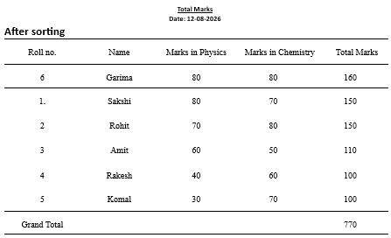

Problem 3. Using a spreadsheet package you have studied, construct T Morongo’s pay slip for December 2016 following the instructions below. Insert a custom footer with your name, subject, course, exam/Test & question number. Save it as Salary advice

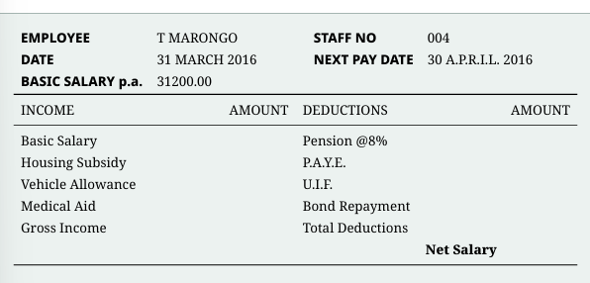

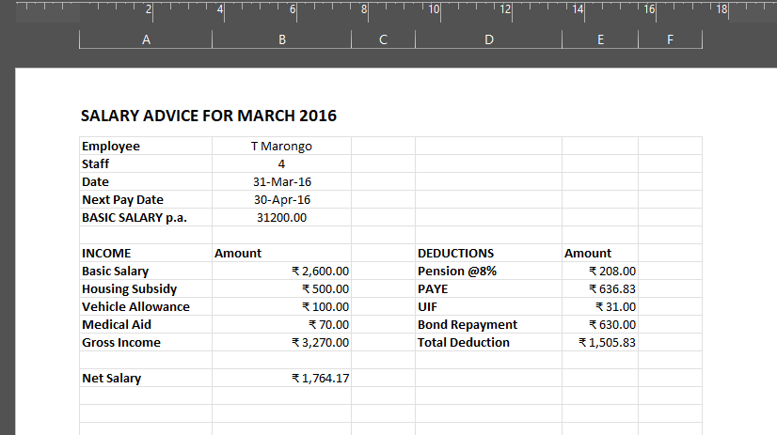

Instructions
- Housing Subsidy 6000.00 per year.

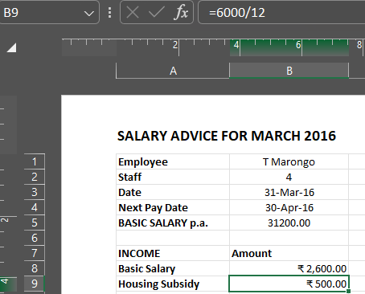

- Car Allowance 100.00 per month.
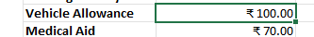

- Pension 8% on Basic Salary.

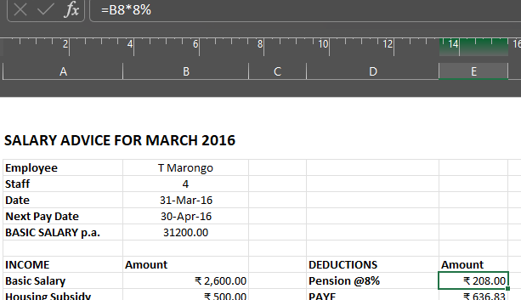

- PAYE 636.83.

- Medical Aid 70.00.

- U.I.F. 1% on Basic Salary + Housing Subsidy.

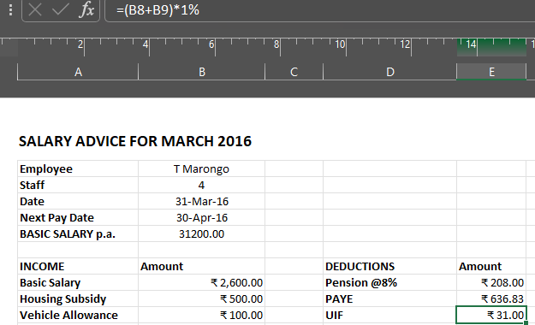

- Bond Repayment 630.00.

- Calculate Net Salary.

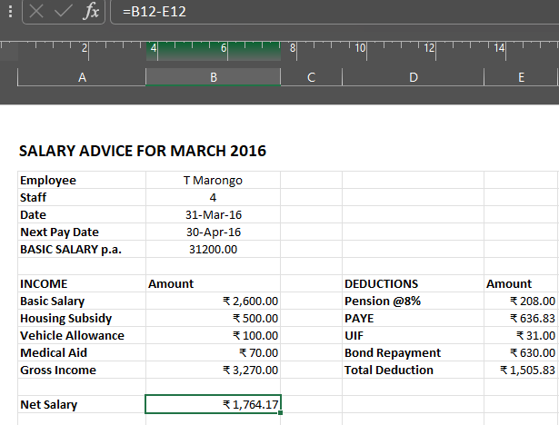

- Format all figures to two decimal places and insert ₹ currency symbol.
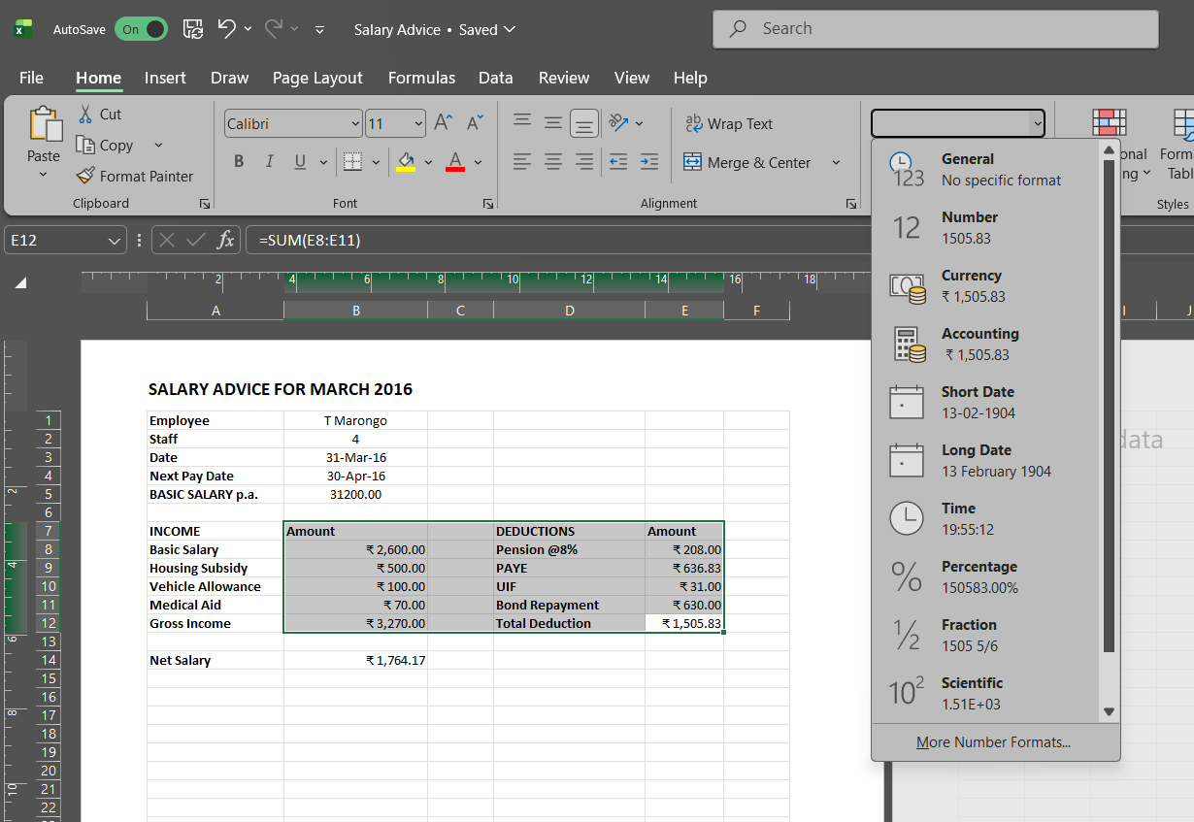
10. Insert a custom footer with your name, subject, and question number. Save it as salary
advice2.

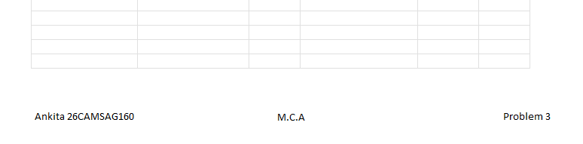

Problem 4. Use a new work book & construct a work sheet with the data given & save it as LYONS.

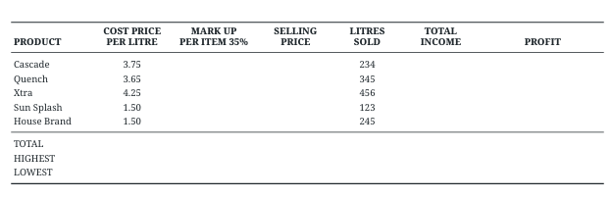
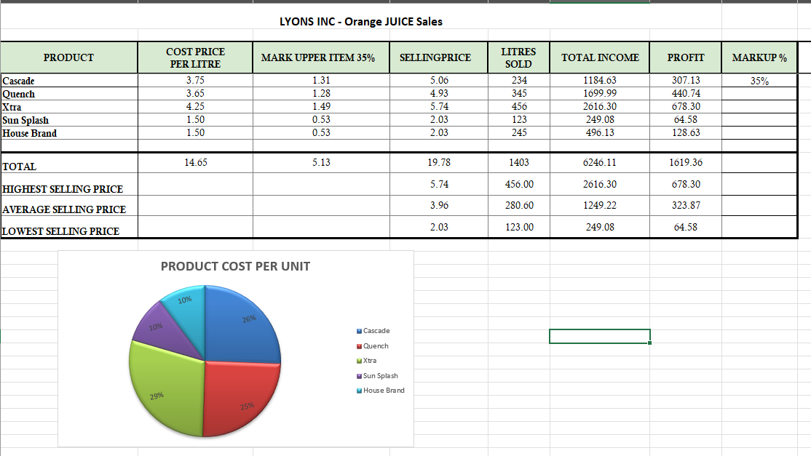

Instructions
- Markup = Cost price/Litre x 35%
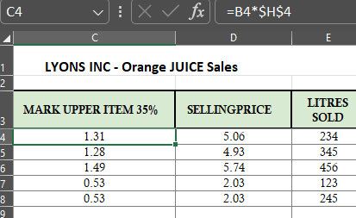
- Selling price = Cost price/Litre + Mark up
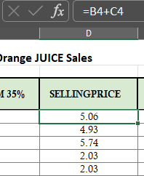

- Total income = Litres sold x Selling Price
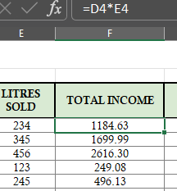

- Profit =Total income- (Cost price/Litre x Litres sold)
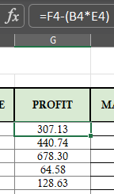
a) The MARKUP%(35%)must be inserted in a separate cell under the heading. USE IT as an absolute cell reference in the formula to calculate the mark up per item.
b) Calculate the mark up for each item.
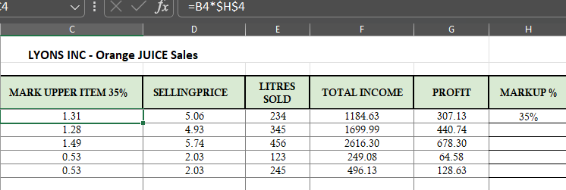

c) Calculate the selling price for each item.
d) Calculate the Total Income for each item.
e) Calculate the profit for each item.
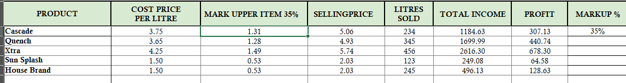
f) Format the column LITRES SOLD to display the number of litres as integers. The rest of
the worksheet must be formatted to display two decimals.
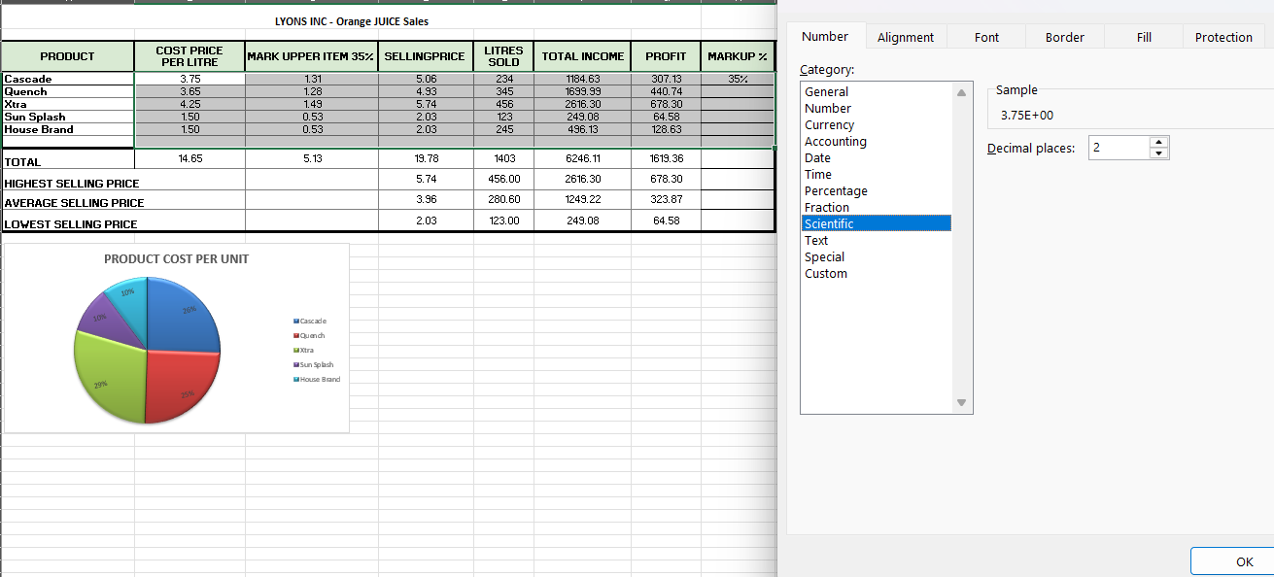
g) Use statistical functions to calculate the AVERAGE, HIGHEST (MAX.) and LOWEST (MIN)
for Selling Price column up to Profit Column.
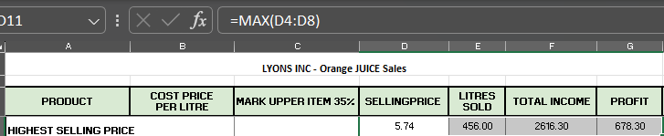
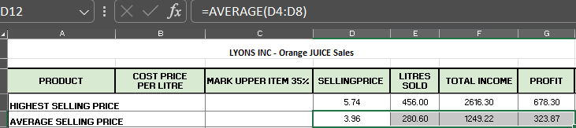
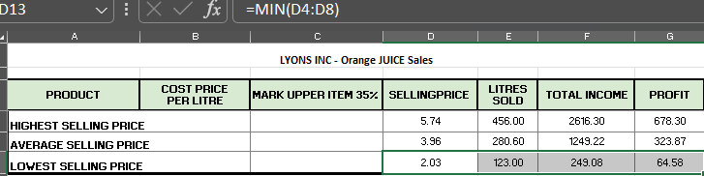
h) Show all formulas you have used in a new sheet. Adjust the column width so that the
formulae are displayed in full and the sheets fits into one side of A4 landscape format
and save it as formulas.
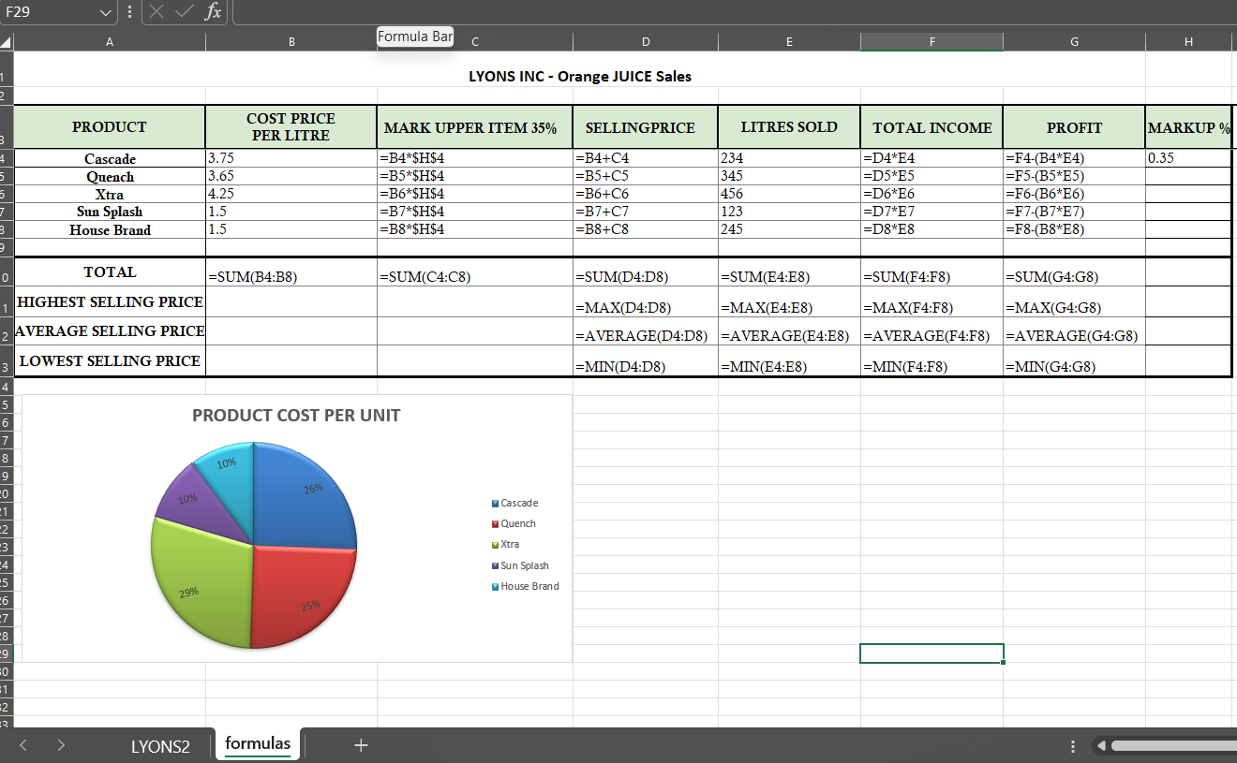
i)Under the worksheet Create a pie chart titled PRODUCT COST PER UNIT for Product &
Cost price per Litre columns. Data labels indicating percentages should be displayed.
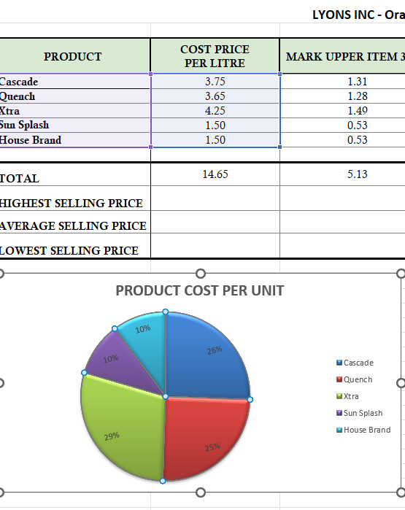

j) Put borders neatly on the on the work sheet & save it as LYONS2
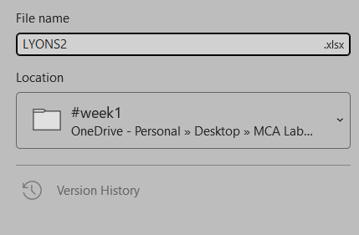

WEEK #2
Fundamentals of IT: MS PowerPoint

OBJECTIVES : To help the students in learning about MS PowerPoint.

OUTCOMES: After completing this, the students would be able to:
Understand the usage of MS-Power Point in real life.

PROBLEMS:
Problem 1. Design Seasonal Greeting cards using MS-PowerPoint.


Problem 2. Design an AMU Magazine cover in MS PowerPoint. Use the following:
- Select a theme for the page.
- Insert either a picture or clipart.

- Use WordArt.

Problem 3. Design a poster inviting all students of your department to the IT Fest (using MS-Power Point).

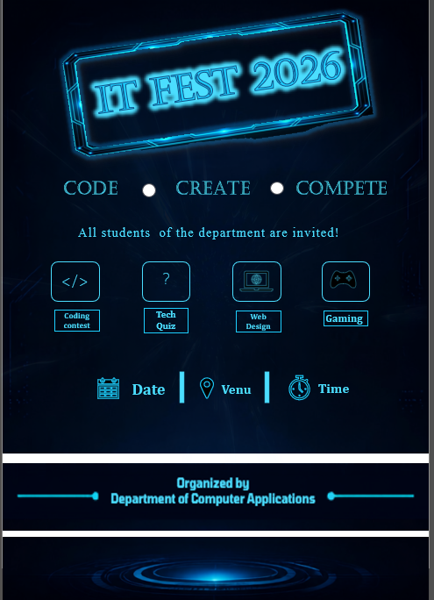

Problem 4. Create a 5-slide presentation on any topic. Use Images, Graphs, Chart, Tables, Animation, Time, Bullets, Transition, Sound, Hyperlink, Background template, Header and Footer (using MS-Power Point).
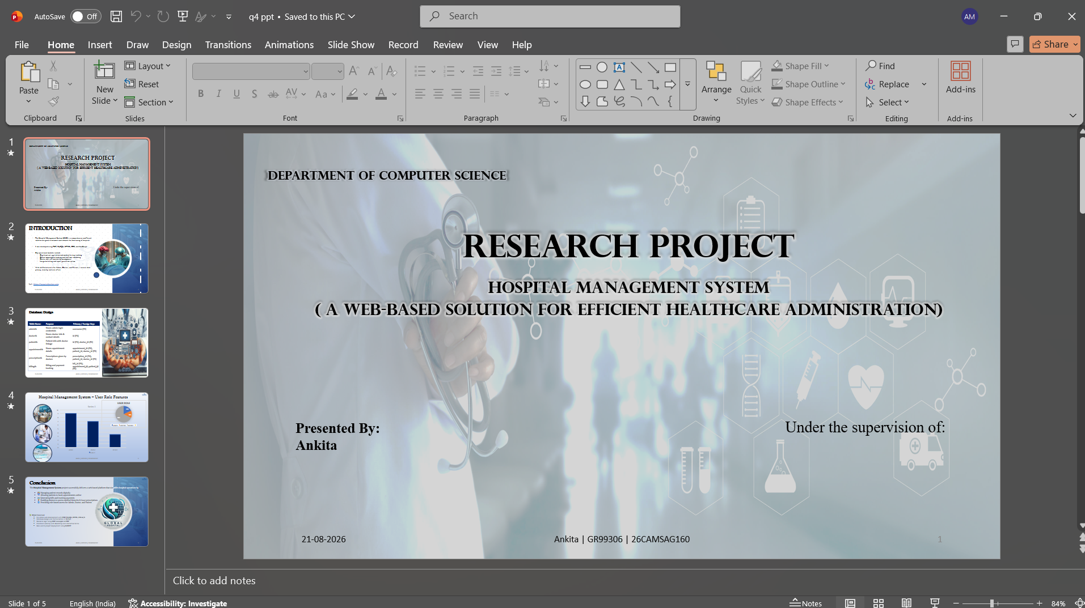
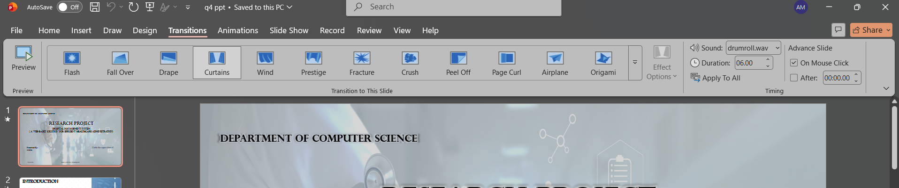

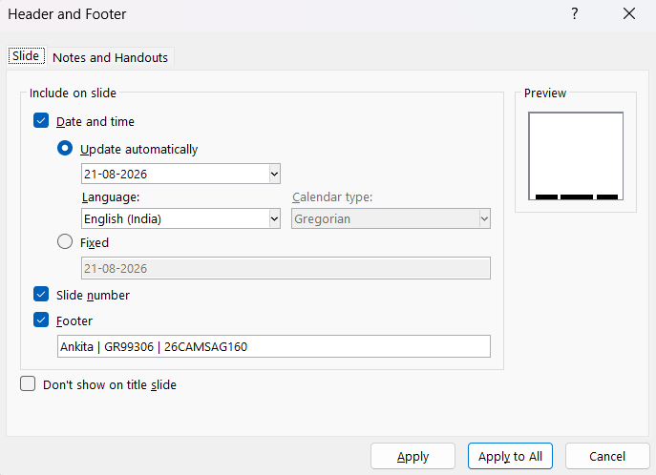
Problem 5. Create a 5-slide presentation on any topic. Use Images, Graphs, Chart, Tables, Animation, Time, Bullets, Transition, Sound, Hyperlink, Background template, Header and Footer (using MS-Power Point).
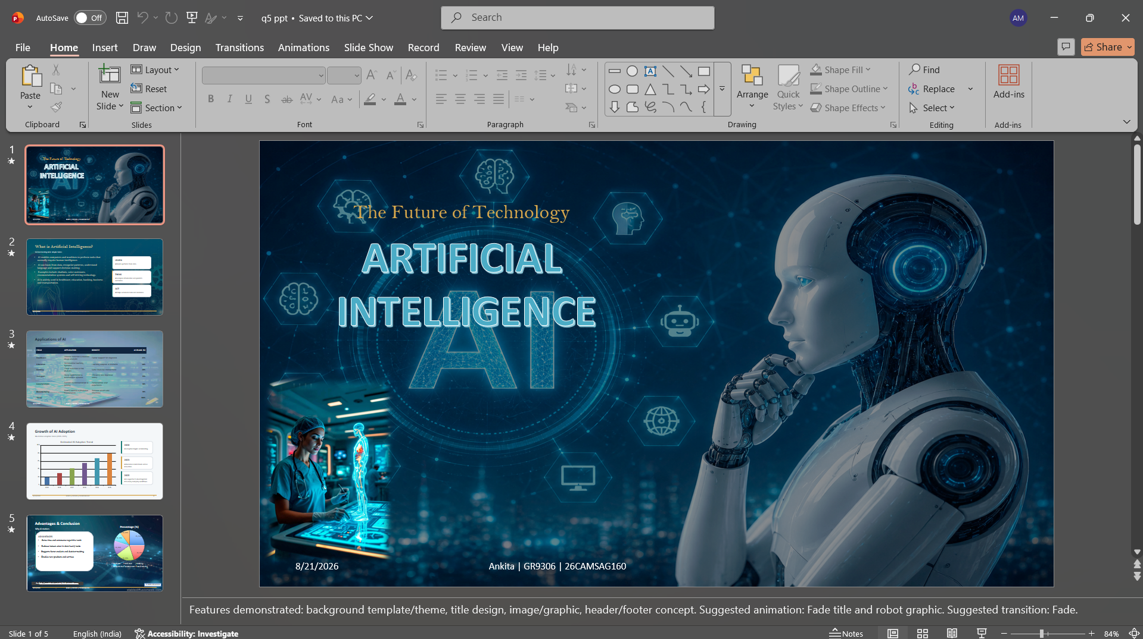
WEEK #3
C++ Environment, IDE Installation and Tool Setup

OBJECTIVES :
- To help the students in learning the concepts of C++.
- To help the students in learning the different tools for C++ programming on different
software platform.
- To help the students install the C++ toolkit on their computers.
OUTCOMES: After completing this, the students would be able to:
- Understand the concepts of C++.
- Setup the C++ environment on a different platform.

Section 1.01 Features of Dev-C++ IDE:
Enlisted below are some of the features of this IDE that help us developing efficient and
user-friendly C/C++ applications.
▶ Dev-C++ supports GCC-based compilers including Cygwin, MinGW, etc. We can either
install a Dev-C++ IDE along with the compiler integrated or just an IDE if we already
have a compiler on our system.
▶ We can use integrated debugging (using GDB) with this IDE. The debugger allows us to
perform all the general debugging operations on source code.
▶ It has a localization feature that provides support for multiple languages. We can select
the language the first time when we open the IDE after installing it. We can also change
the language anytime using settings.
▶ Like the other IDEs, this IDE also provides the ”Auto-Completion” feature for the code
We write.
▶ It comes with customizable syntax highlighting editor that can make the source code
more readable.
▶ Allows editing and compiling the Resource files.
▶ Has a Tool Manager that contains various tools that can be used in the project.
▶ This IDE also has inbuilt Find and replace facilities.
▶ Using Dev-C++ IDE, we can create various types of applications be it Windows, Console,
Static libraries or DLLs.
▶ We can also create our own project templates to create our own project types.
▶ Make files that are used for managing the build process for the application can also be
created using dev-C++ IDE.
▶ It provides support for Class Browser as well as Debug variable Browser.
▶ It has a Project Manager that helps us to manage various projects.
▶ Also provides print support through its interface.
▶ We can easily install the add-on libraries using the package manager provided by the
IDE.
▶ This C++ IDE also provides CVS support for source code management.

Section 1.02 Installing and Configuring C++ IDE
We can get the appropriate installable for dev-C++ IDE from http://www.bloodshed.net/
dev/devcpp.html Let’s see the entire installation process now. We have used the installable
that comes along with the C++ compiler. In this tutorial, we use the dev-C++ version 5.11
with the TDM-GCC 4.9.2 compiler. The stepwise installation for dev-C++ is given below.
- The first step while we start the installer is to select the language of our choice as shown
in the below screenshot.
- Once you select the appropriate language, you have to agree to the license agreement
that pop-ups next.
- Next, we are asked to select the components that we need to install as a part of the
dev-C++ installation. As shown in the above screenshot, we are provided with a list of
components available for installation and a checkbox against each component. We can
check/uncheck each box to indicate which components to install. Click next once the
components are selected.
- Now the installer prompts the user for the destination folder where the dev-C++ files/
libraries etc. are to be copied. Once we provide the destination folder path, click on
Install.
- The following screenshot shows the progress of the installation. Once the installation
is over, a ”finish” dialog that signals the end of the installation appears. We click finish
and then we can launch the dev-C++ IDE. Now let’s see the working of this C++ IDE in
detail.
(a) Development Using Dev-C++ IDE
(b) Configuring Dev C++
(c) Change Linker Setting for Debugging
After starting the IDE, the first thing we need to ensure is the setting for debugging information to be generated. Follow the steps below to set the debugging information.
▶ To change this setting, click on Tools → Compiler Options.
▶ Then click on the ”Settings” tab on the dialog that pops up.
▶ Under” Settings”, we have a ”linker” tab.
▶ In the ”linker” tab there are various options shown. Set ”Yes” for the option ”Generate
Debugging Information (-g3)”. This is shown in the following screenshot. Click OK, once
done.
(d) Create a New Project
To create a new project in dev-C++ we need to follow the below steps
▶ Click File → New →Project.
▶ A new dialog opens up as shown below.
▶ Here ,we can specify the project name. Make sure to select the ”Empty Project” and also
to check the ”C++ Project” button.
▶ Once the entire information is provided, we can click ok and the IDE will ask for the
path where the project is to be saved. When this is done ,a workspace will open with the
project explorer on the left-hand side that shows the project we just created.
▶ Now we can add or import the code files into this project.
(e) Add Source File(s)
Adding a file to a project can be done in two ways. 1. Add a new file by clicking Project
→New File or Right-click on Project Name in the project explorer and click New File. 2.
Another way is to add the existing files to the project. This can be done by clicking Project
→Add to Project or right-click on Project Name in the project explorer and select ”Add to
Project…” This will give a dialog to select files and import them to the project. 3. Once the
files are added to the project, the workspace looks as shown below.
(f) Compile/Build & Execute Project
When we have all the code ready for the project, we will now compile and build the
project. Follow the below steps to build and execute the dev C++ project:
▶ To compile the project, click Execute → Compile (or click F9).
▶ We can see the compilation status in the ”Compile Log” tab in the workspace.
▶ If there are any errors whether syntax or linker errors, then they will appear in the
compiler tab.
▶ Once the project is compiled successfully, we need to run it.
▶ Click on Execute →Run. (or click F10)
▶ The console window that gives us the output will be shown in the below screenshot.
▶ If there are command line parameters to be passed to the program, we click on Execute
→Parameters. This will open a dialog using which we can pass parameters.
(g) Debugging In C++ IDE
Sometimes we may not get the desired output from our program although the program
is syntactically correct. In such a situation, we can debug the program.
The dev-C++ IDE provides the inbuilt debugger. Follow the below steps to debug the pro
gram using Dev-C++ IDE:
▶ Click Execute →Debug. (or click F5).
▶ Once the debug is clicked, we get the debug menu in the IDE, as shown below.
▶ Before debugging we can toggle breakpoints using F4 at a particular line of code.
▶ Using the debugmenu,wecanuseoptionslikeaddwatches,runtocursor,intofunction,
etc. to efficiently debug our program.
Article II. Setting up Code::Blocks on Windows
This tutorial gives you easy-to-follow instructions, with screenshots, for setting up a com
piler (the MINGW compiler), a tool that will let you turn the code that you write into pro
grams, and Code::Blocks, a free development environment for C and C++. This tutorial ex
plains how to install Code::Blocks on Windows 2000, XP, Vista or Windows 7.

▶ Goto this website: http://www.codeblocks.org/downloads
▶ Follow the link to ”Download the binary release” (direct link)
▶ Goto the Windows 2000/XP/Vista/7section
▶ Look for the file that includes mingw in the name. (The name as of this writing was
codeblocks-10.05mingw-setup.exe; the 10.05 may be different).
▶ Save the file to your desktop. It is roughly 74 megabytes.
Section 2.02Step 2: Install Code::Blocks
▶ Double click the installer.
▶ Hit next several times. Other setup tutorials will assume you have installed in
C:\Program Files\CodeBlocks (the default install location), but you may install else
where if you like
▶ Do a Full Installation
▶ Launch Code::Blocks
Section 2.03Step 3: Running in Code::Blocks
You will be prompted with a Compilers auto-detection window: When you get the com
piler auto-detection window, just hit OK. Code::Blocks may ask if you want to associate it
as the default viewer for C/C++ files–I’d suggest you do. Click on the File menu, and under
”New”, select ”Project...” The following window will come up: Click on ”Console Application”
and hit the ”Go” button. Click next until you get to the Language Selection Dialog: You’ll be

SCREENSHOTS:
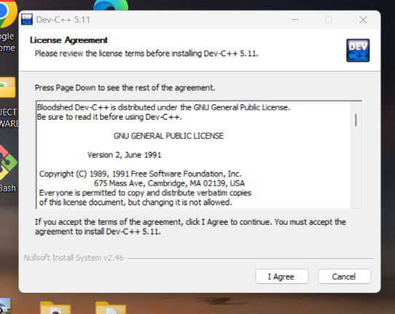
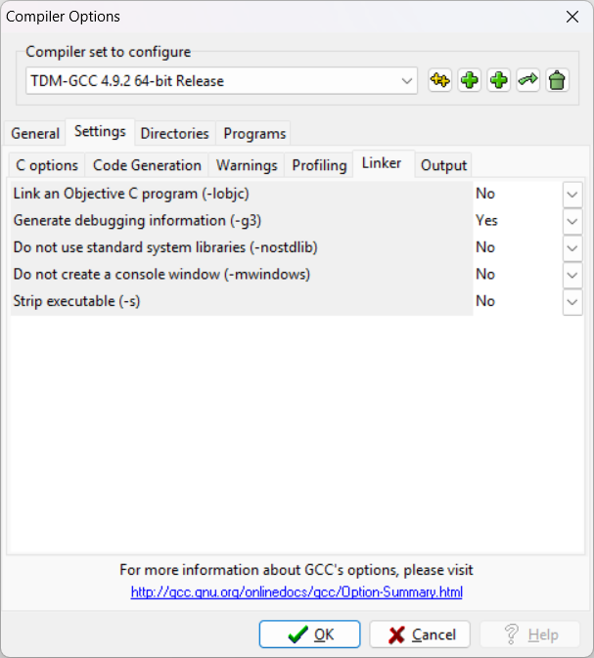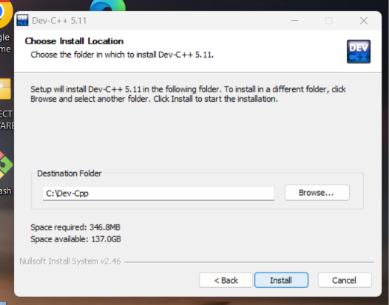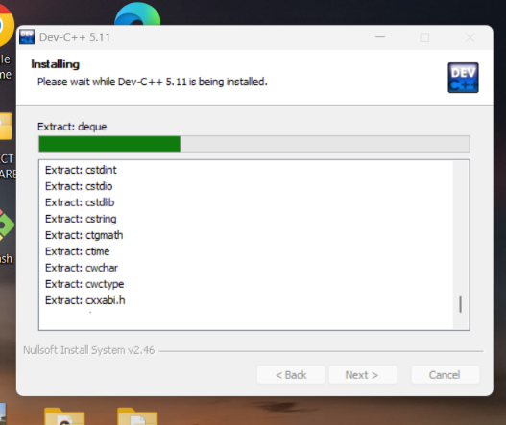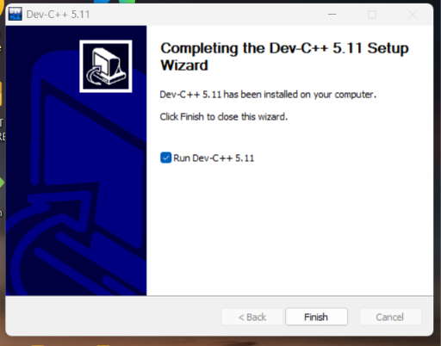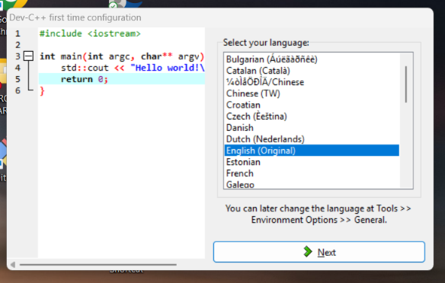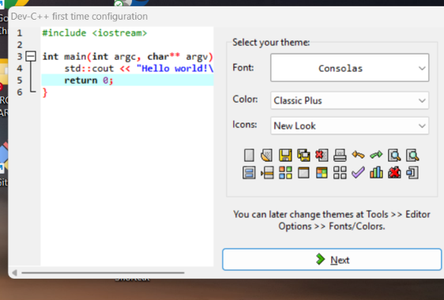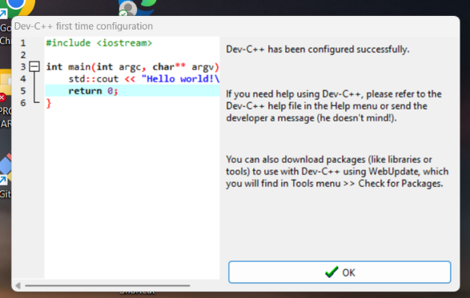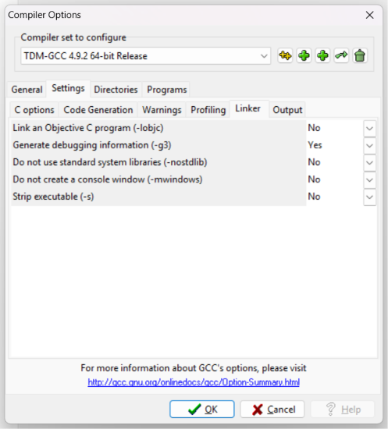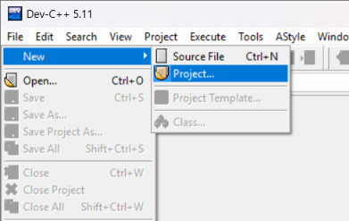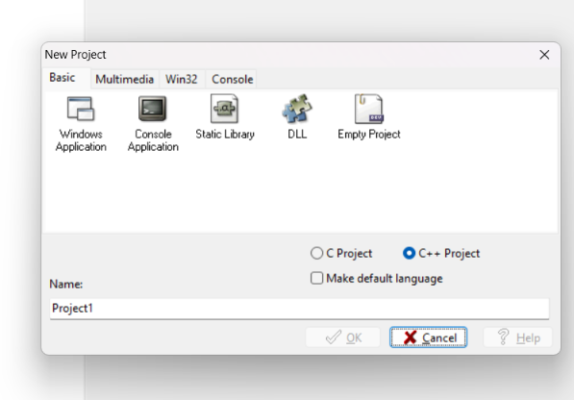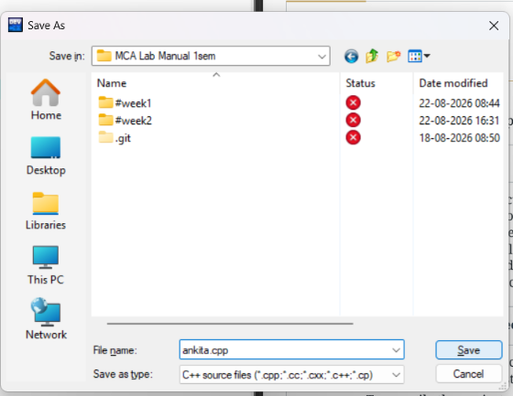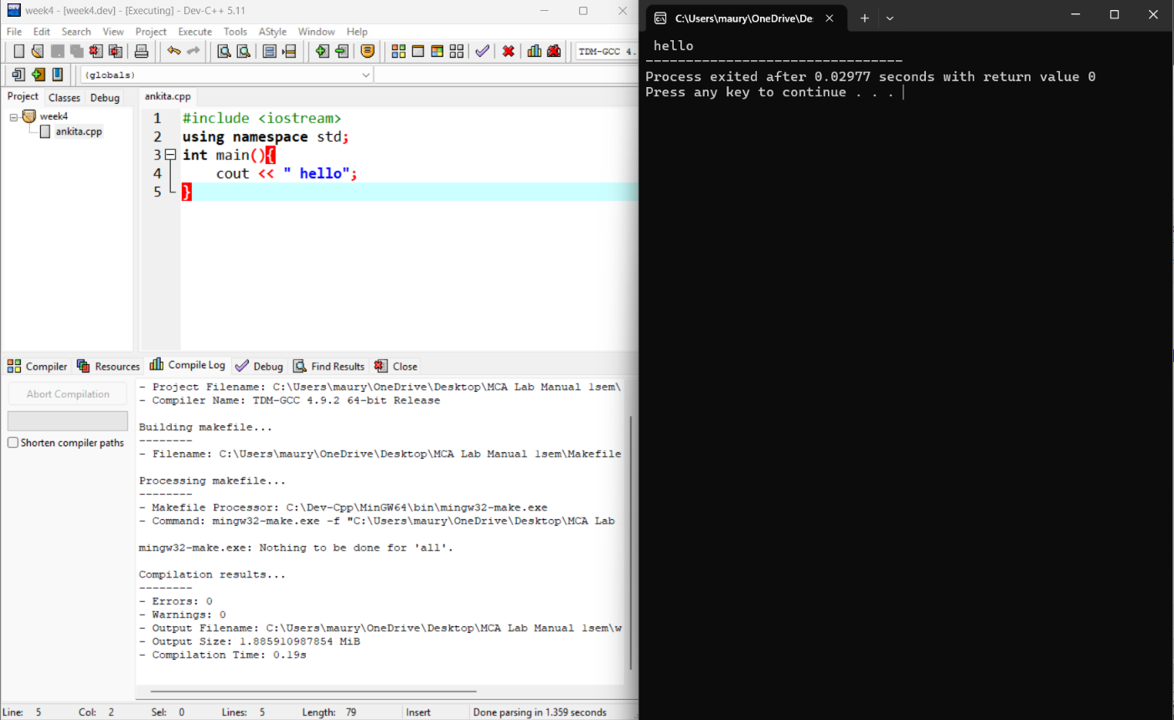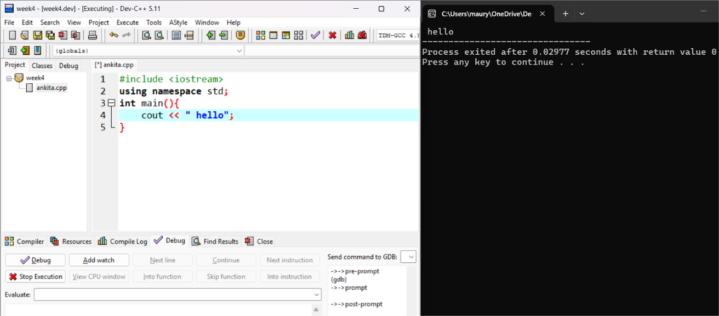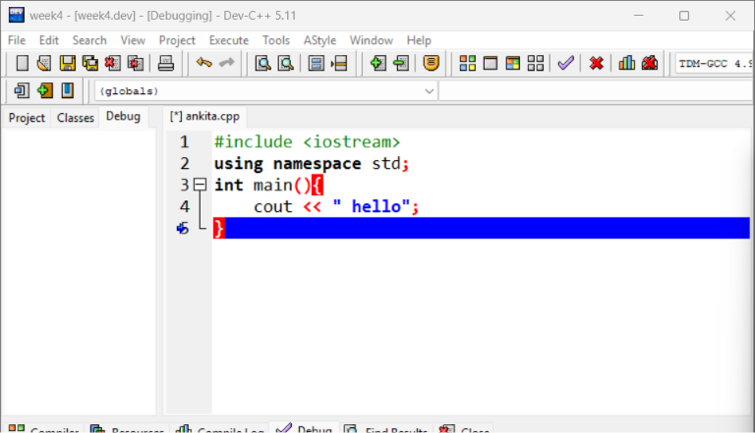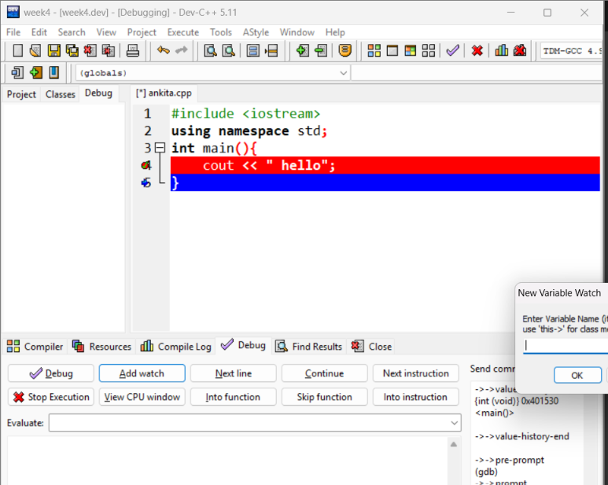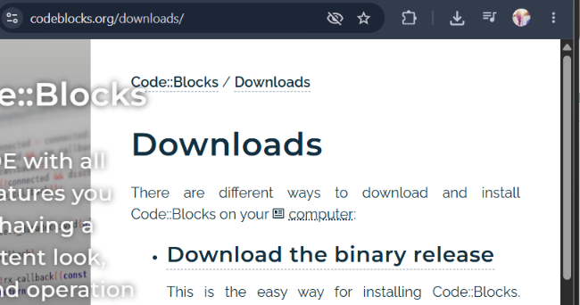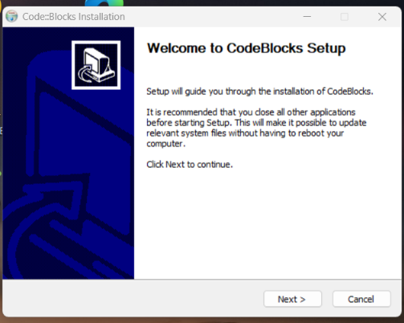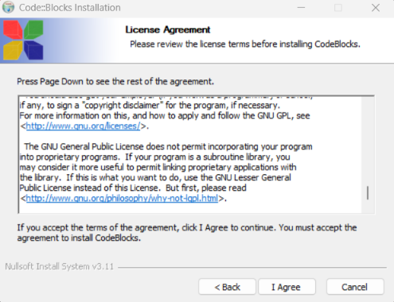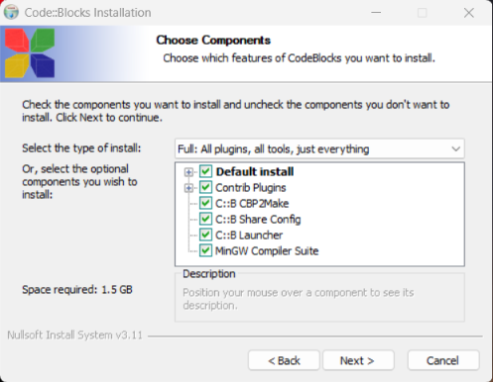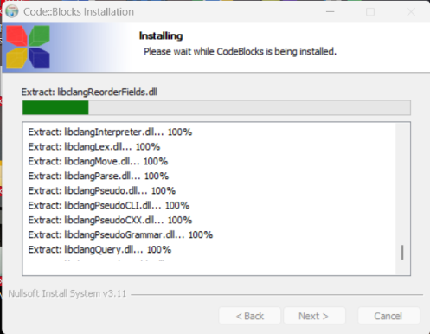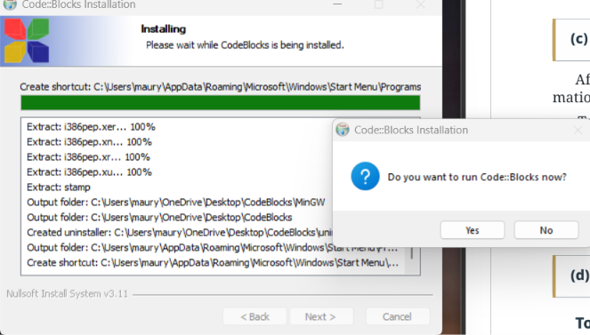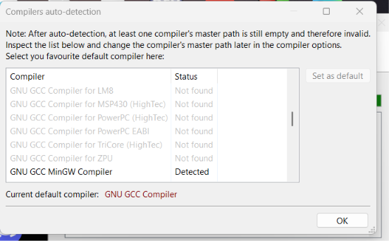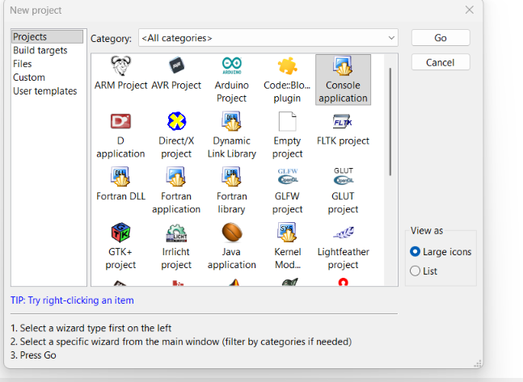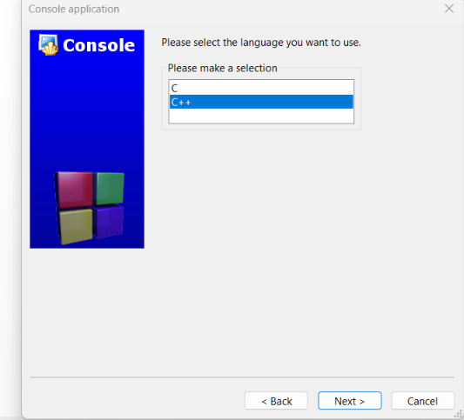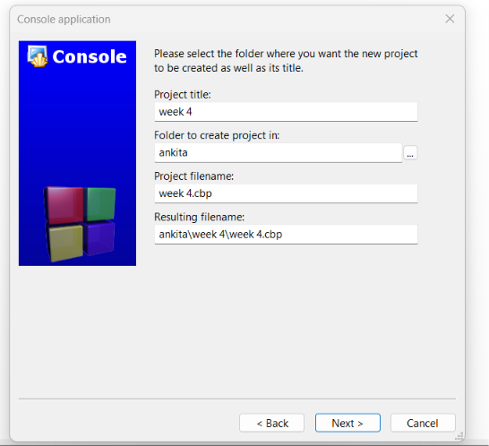

WEEK #4
C++ Operators, Decision-Making and Control Statements

OBJECTIVES:
▶ To help the students in learning the concepts of C++.
▶ To help the students in learning about the different operators available in C++.
▶ To help the students in learning the different decision-making statements and control
statements used in C++.

OUTCOMES: After completing this, the students would be able to:
▶ Understand the concepts of C++.
▶ Understand the usage of various operators and their precedence in expression evaluation.
▶ Understand the usage of decision-making statements and control statements of C++ in real
life applications

PROBLEMS:
Problem 1. Write a C++ program to check whether a number is even or odd using ternary operator.
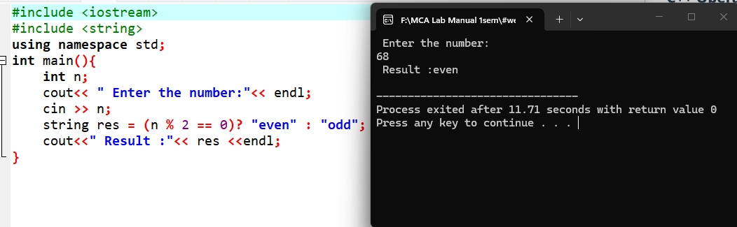

Problem 2. Write a C++ program to perform the addition of two numbers without using + operator.

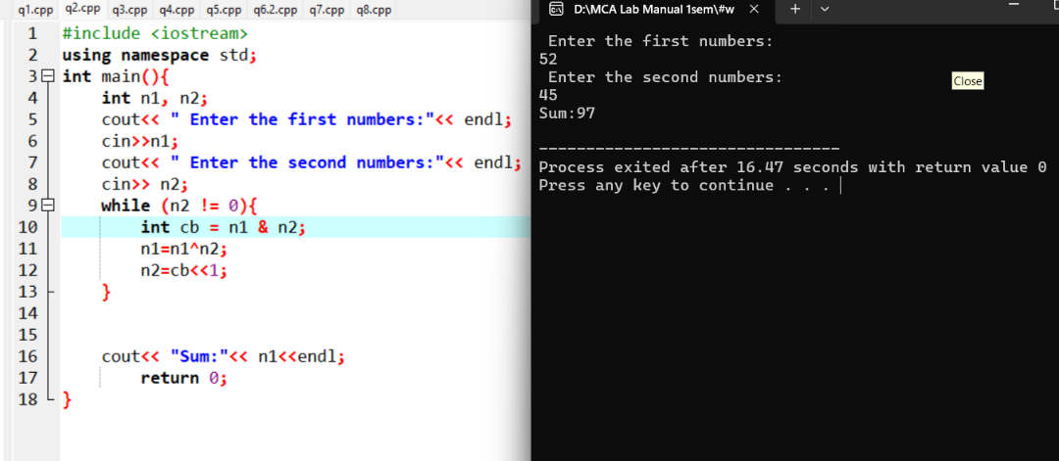

Problem 3. Write a C++ program to evaluate the arithmetic expression ((a + b / c * d- e) * (f- g)). Read the values a, b, c, d, e, f, g from the standard input device.
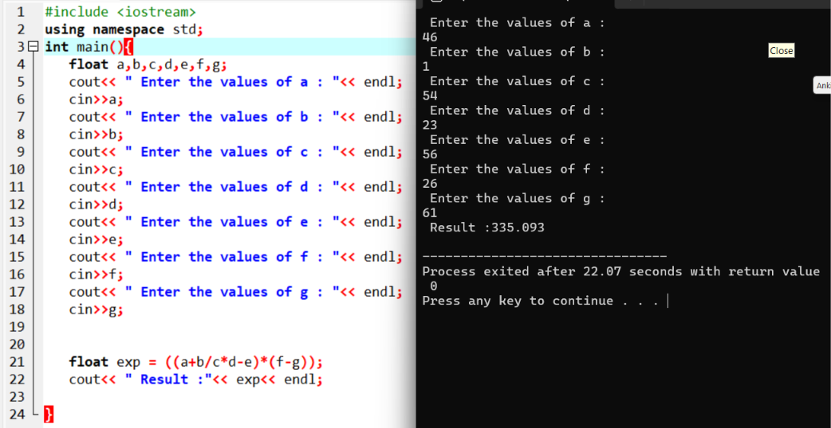

Problem 4. A Fibonacci sequence is defined as follows: The first and second terms in the sequence are 0 and 1. Subsequent terms are found by adding the preceding two terms in the sequence. Write a C++ program to generate the first n terms of the sequence.

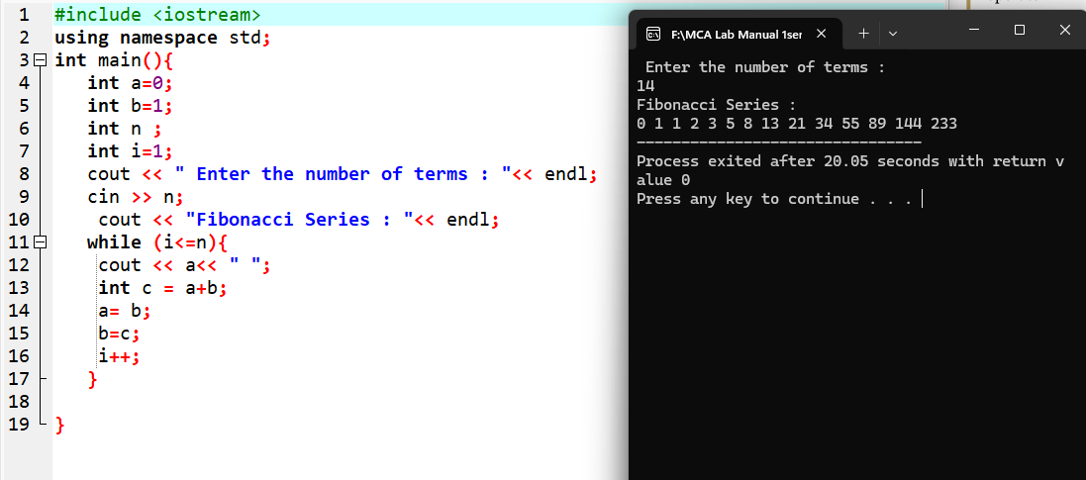

Problem 5. Write a C++ program to generate all the prime numbers between 1 and n, where n is a value supplied by the user.
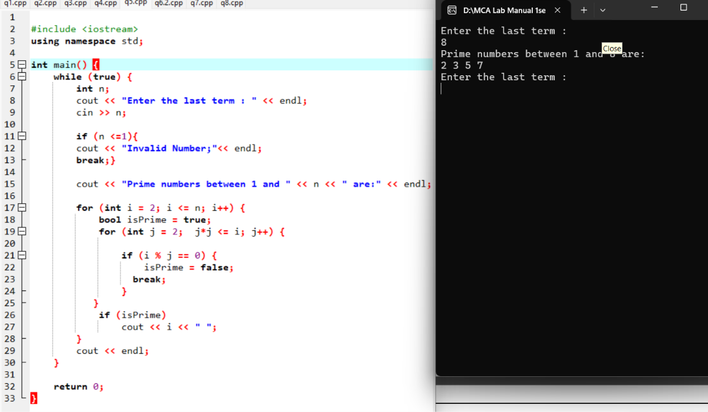
Problem 6. A character is entered through keyboard. Write a C++ program to determine whether the character entered is a capital letter, a small case letter, a digit or a special symbol using if-else and switch case. The following table shows the range of ASCII values for various characters. Characters ASCII values A– Z: 65– 90, a– z: 97– 122, 0– 9: 48– 57 Special symbols 0– 47, 58– 64, 91– 96, 123– 127.
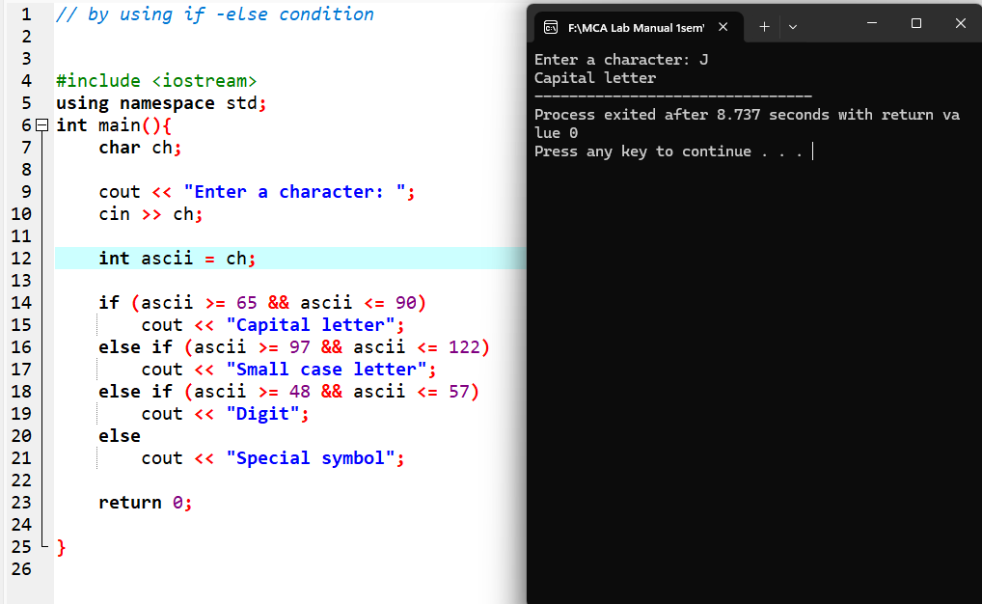

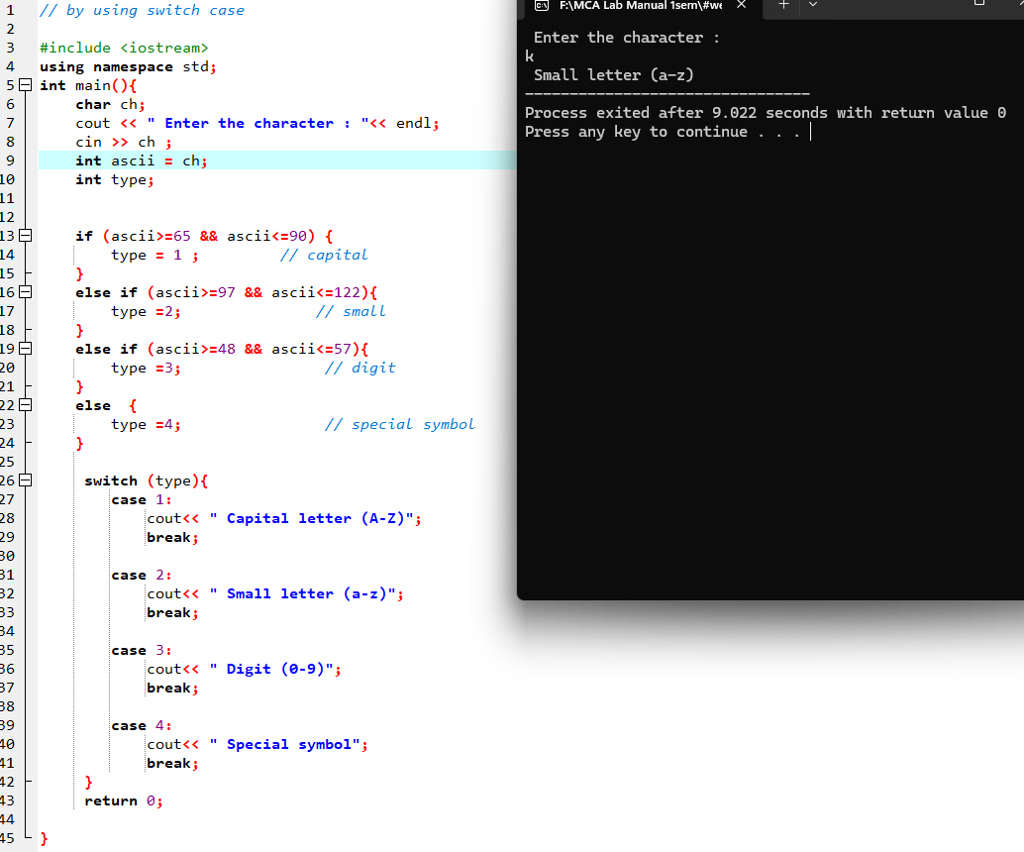

Problem 7. Write a C++ program to find the roots of a quadratic equation.

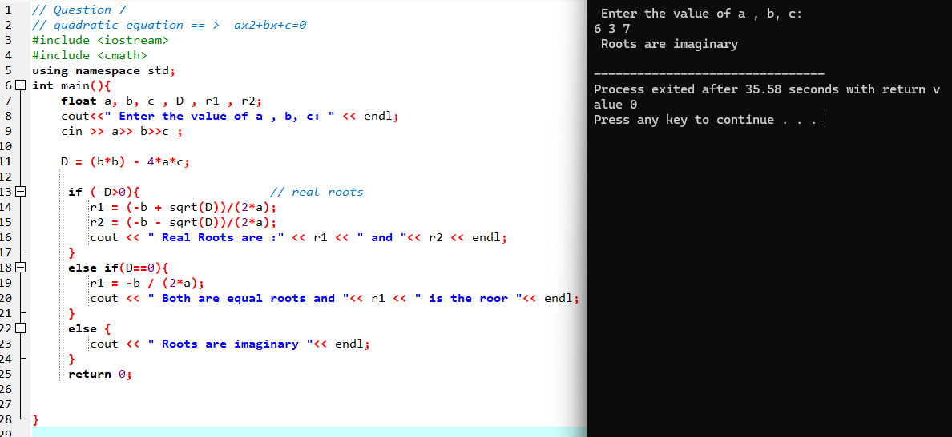

Problem 8. Write a C++programtocheckwhetheragiven3-digit number is an Armstrong number
